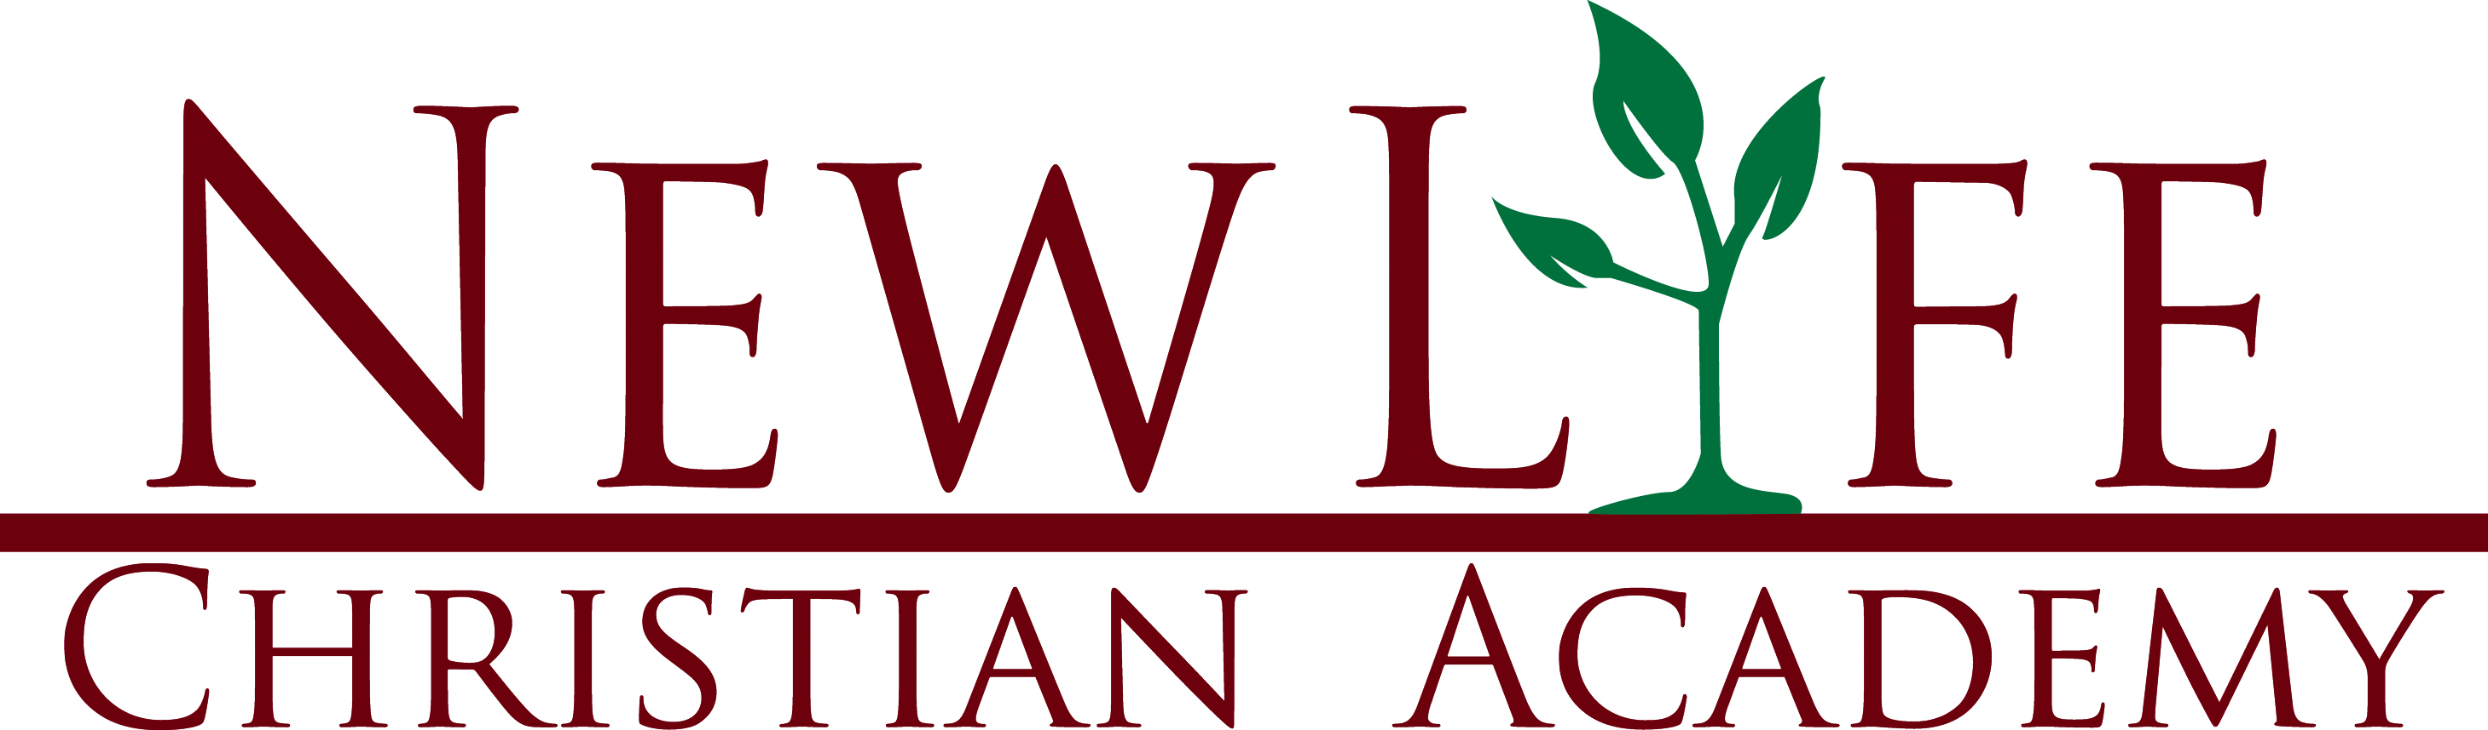
899 Broad Street, Summersville, WV 26651
304-872-1148 www.nlca.info

2021 – 2022 REGISTRATION FORM

PLEASE PRINT: Complete entire form and return to the school office with your non-refundable registration fee. This information is extremely important for inclusion in your child’s permanent records. ALL RECORDS ARE KEPT CONFIDENTIAL AND SEEN ONLY BY OFFICE PERSONNEL AND YOUR CHILD’S TEACHER. If any information changes, please contact the school immediately.

For office use only: Secretary __________ Bookkeeping __________ Food Program _________

STUDENT INFORMATION

Name________________________________________________________________________________________ Last First Middle (Other)

Birth Date ______/______/_______
A Certificate of Live Birth, Social Security Card, and Immunization Record must be provided for all new enrollments.

Grade Entering ____________ Gender: F___ M___ Student’s Home Phone___________________________

Check One: New Enrollment to NLCA__________________ Returning Student to NLCA___________________

Transportation Method: NLCA Van__________ Public Bus__________ Other________
*Van transportation must be approved by the office prior to enrollment and payments are from August to May.

FAMILY INFORMATION

Mother’s Full Name________________________________________ Primary Phone Number_________________

Father’s Full Name ________________________________________ Primary Phone Number_________________

Student’s Mailing Address _______________________________________________________________________

Student Resides With __________________________________________________________________________

Siblings (Names) ______________________________________________________________________________

Parent’s Marital Status: _____________Single ___________Married ___________Divorced

Parent Primary Email Address: ___________________________________________________________________
For online grades, tuition/lunch billing, communication, etc.

EMERGENCY CONTACT INFORMATION

Name _________________________ Relationship to Student _________________ Phone _________________

Name _________________________ Relationship to Student _________________ Phone _________________

Church Affiliation ______________________________________________________________________________

Pastor’s Name ___________________________________ Youth Pastor__________________________________

MEDICAL INFORMATION

Name of Child’s Physician _______________________________________________________________________

Medical Conditions or Allergies ___________________________________________________________________

Maintenance Medication(s) Child Takes ____________________________________________________________
*If medication is to be given during regular school hours, all
prescriptions, as well as all over-the-counter medications, must
be provided to the school secretary with written instructions.

Does your child have any physical restrictions? _____________________________________________________

____________________________________________________________________________________________

ADDITIONAL INFORMATION

Person(s) authorized to pick up children _____________________________________________________________

_____________________________________________________________________________________________

_____________________________________________________________________________________________

_____________________________________________________________________________________________

Person(s) NOT authorized to pick up or visit children ___________________________________________________

_____________________________________________________________________________________________

If a court order is available, please give a copy to school secretary.

Parent/Guardian Signature ____________________________________________ Date ______________________

WEB RELEASE FORM

As a student at New Life Christian Academy, often your child may create classroom projects or have photographs taken of him or her. Many times we like to use these items in ways such as, but not limited to the following: the Internet, brochures, and DVD’s.

If you permit the staff of New Life Christian Academy to use, produce, and/or display your child’s materials and photographs please sign below.

Student Name_________________________________________________________

Parent Signature_____________________________________________________

Date_________________________________________________________

If at any time your desire for the usage of your child’s materials/photographs changes, please notify us in writing.

ACCIDENT TREATMENT RELEASE

In case of accident or serious illness and I cannot be reached, I give the staff of New Life Christian Academy permission to obtain medical attention for my child at the closest physician or medical institution. This agreement will be effective for the 2021-2022 school year.

STATEMENT OF CO-OPERATION AND PARENT AGREEMENT

I agree to support the teachings, and the authority of the school in the Spirit of Christ. I agree that if my child should become involved in any conflict at school, or if I disagree with any policy or discipline measures set by the school, I will abide by the following school’s conflict resolution policy:
- Contact and meet with the teacher involved
- If the matter is not resolved, meet with the teacher and the principal
- In the unusual event that the grievance still exists, meet with the School Board which will reach a decision to the best interest of all involved

Additionally, I agree to familiarize myself with the NLCA Student Handbook and support all policies of the handbook which is posted on the school’s website www.nlca.info .

TUITION PAYMENTS

I agree to pay tuition and such fees as are chargeable according to the current Schedule of Tuition Fees. It is also my understanding that the policy of the school is to make no refunds on registration fees. Payments are due from June to May.

SCHOOL OUTING PERMISSION

Most field trips are planned well in advance, and individual permission slips are sent home with detailed information. However, there are instances that arise when the students may need to leave campus. Some examples of this may include, but are not limited to: Reward Treats, National Day of Prayer, and Community Activities. For these special circumstances that are deemed appropriate by school administration, I give my permission for my child to participate and be transported via school approved transportation.

I have read and agree to the above statements:

Parent/Guardian Signature_________________________________________________

Date __________________________________________________________________

New Life Christian Academy
Accepted Use Policy Form

Dear Parent/Guardian,

Internet access is available to the students and teachers at New Life Christian Academy. We are pleased to bring this access to NLCA, and believe the Internet offers vast, unique and diverse resources to both students and teachers. Our goal in providing this service is to promote educational excellence in our school. Your son or daughter may have the opportunity to access and use the Internet as part of their schoolwork in the classroom or the computer lab.

With access to computers and Internet sites all over the world also comes the potential availability of materials that some people may find objectionable. NLCA has taken precautions to ensure that students access only information that is consistent with the goals of our instructional program and restrict access to controversial materials.

Accepted Use Policy

The use of the Internet is a privilege, not a right, and inappropriate use will result in the cancellation of those privileges. The student is expected to exercise responsible behavior when on the Internet:

- Students will be polite and use appropriate language when communicating with others on the Internet.
- Using the Internet for non-school related activities is unacceptable.
- Students will respect copyright laws.
- Students will respect the computer equipment at all times.
- Students will respect the privacy of others, and will not reveal their name, personal address or phone number, or that of other students. Nor will they post their picture or that of another student online.
- Students will not attempt to override security measures and enter controversial sites or chat rooms.
- Students, in or out of school, are expected to exhibit moral, Christian behavior when using any form of social media, as they are a representation of New Life Christian Academy.

Policy Consent Form

I have read the Accepted Use Policy as established at New Life Christian Academy and understand its contents. Any questions about Internet activities will be answered by the teacher. My signature below, and that of my parent(s) and/or guardian(s) indicates that I agree to follow the guidelines of using the Internet as stated in this document.

Student Signature______________________________________ Date _____________

Parent/Guardian Signature __________________________ Date ____________

NEW LIFE CHRISTIAN ACADEMY'S
STATEMENT OF FAITH

- We believe the sixty-six books of the Old and New Testaments of the Bible to be the only inspired, infallible and authoritative Word of God.
- We believe in one God, infinitely perfect and eternally existent in three persons: Father, Son, and Holy Spirit.
- We believe that through divine creation, in the space of six days, all life and matter came into being.
- We believe that by one man, Adam, sin entered the world; that all mankind is therefore lost; and that for salvation of the lost, regeneration by the Holy Spirit through faith in our Lord Jesus Christ is absolutely necessary.
- We believe in the deity, virgin birth, and miracles of our Lord Jesus Christ; that He died upon the cross as a substitutionary sacrifice for sin; that He arose from the dead and ascended into heaven to the right hand of the Father, from whence He will return in power and glory.
- We believe in justification by faith, realizing it is impossible for man, through works, to please God or save himself.
- We believe in the resurrection of both the saved and the lost; the saved unto everlasting life and the lost unto eternal punishment and damnation.
- We believe in the present ministry of the Holy Spirit by whose indwelling the Christian is enabled to live a Godly life.
- We believe in the spiritual unity of all believers within the body of Christ.
- We believe the Biblical covenant of marriage as being between one man and one woman.

We agree with the statement of faith and the expectation of Christ-like conduct that is essential for New Life Christian Academy students.

Parent Signature______________________________________
Student Signature_____________________________________

